Term Project – Final Deliverable

- Business Rules:
Use Case 1:
Entity: Seller, Product, List (product list), Product category.
Business rule: 1) A seller must have at least one listing.
2) A listing can have many sellers.
3) A product is linked to at least to one category.
4) A category contains one or more products
5) A product is in at least one listing.
6) A Listing contains at most one product
7) A seller sells many products.
8) A product is sold by at least one seller.

Use Case 2:
Entity: Seller, Product, Consumers, Inventory
Business rules: 1) A seller can ship one or more Product.
2) Product is shipped by one seller.
3) Product has at least one unit of inventory.
4)Inventory can have many products.
5) Consumer can purchase one or more products.
6)A product can be bought by one or many consumers.

User Case 3:
Entity: Consumer, product, Account
Business Rules: 1) A consumer can purchase one or many products.
2) A product can be purchased by one or many consumers.
3) A consumer can have one account.
4) An account can have one consumer.

User Case 4:
Entity: Consumer, Account, Products, Inventory, Order
Business Rules: 1) Consumer can have one account.
2) An account can belong to only one consumer.
3) Consumer can select one or more product.
4) Product can be selected by at least one consumer.
5) Product can be in many inventory.
6) Inventory can have only one product.
7) A consumer can select only one shipping speed.
8) Only one shipping speed can be selected by a consumer.
9) A Consumer can track multiple orders.
10) An order can be tracked by only one consumer.
(I changed sellers’ inventory to inventory)

User Case 5:
Entity: Product, Consumer, Shipment, Order
Business Rules: 1) A product can have one shipment.
2) A shipment can have only on one product.
3) The products are linked to consumer’s order.
4) A consumer’s order can have many products linked.
5) An order can have only one shipment (address).
6) A shipment can have many orders.
7) A consumer can have many shipments.
8) A shipment can be provided to only one consumer.

- Conceptual ERD:
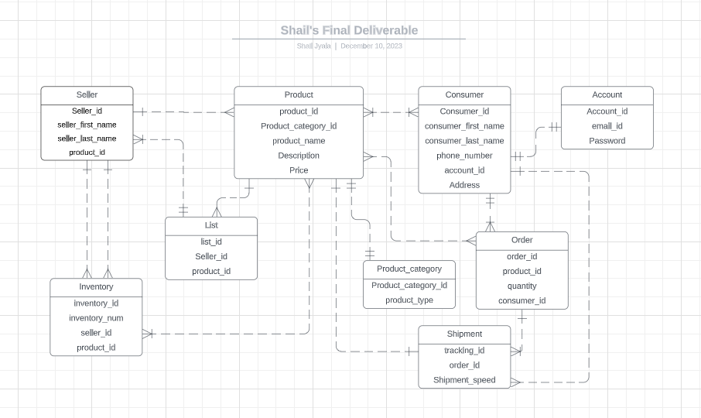

- Logical ERD:
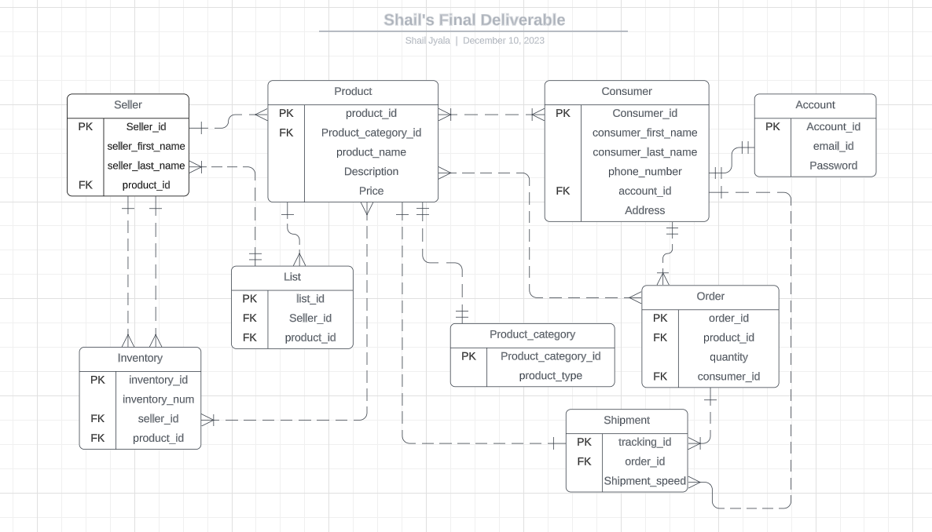
- Aspect 1:
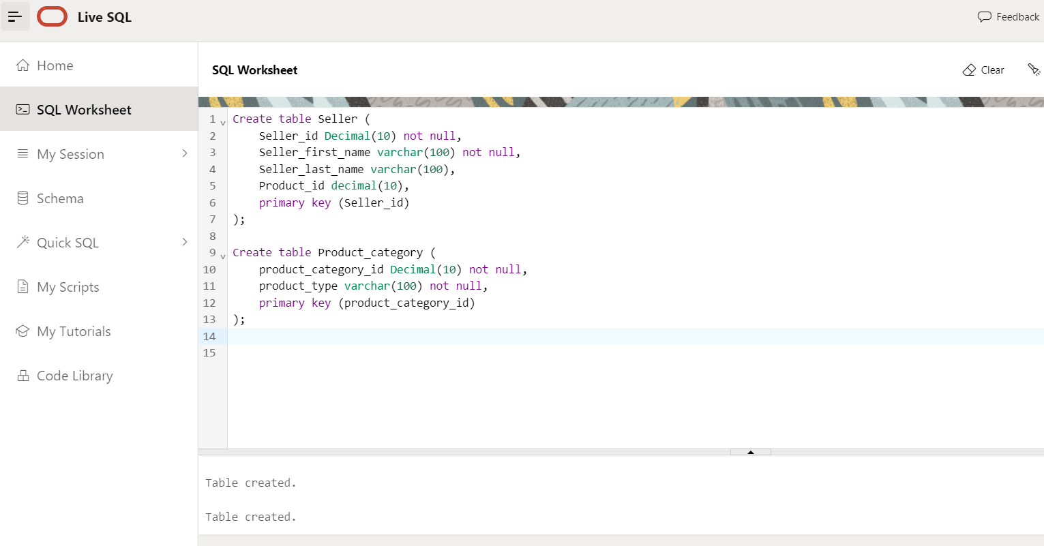

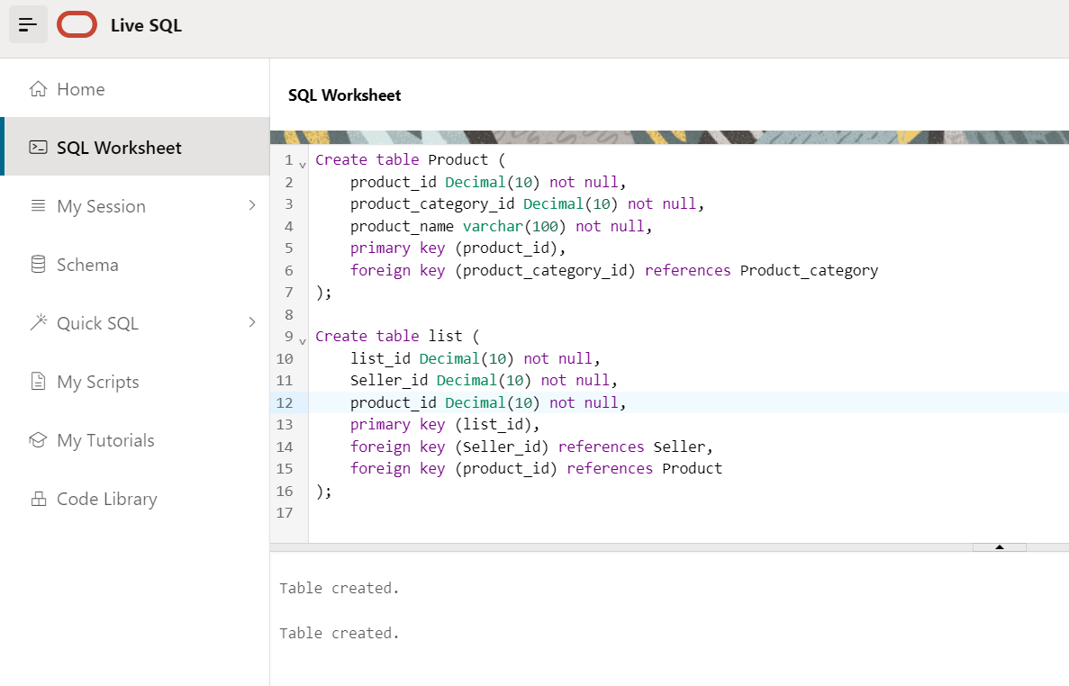

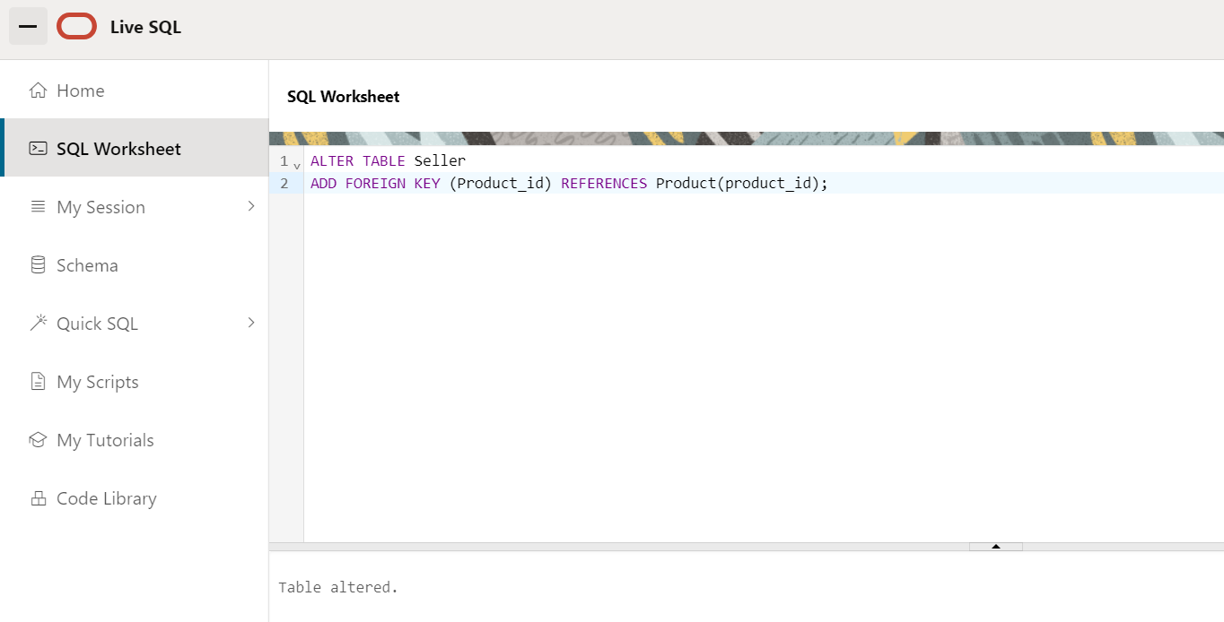
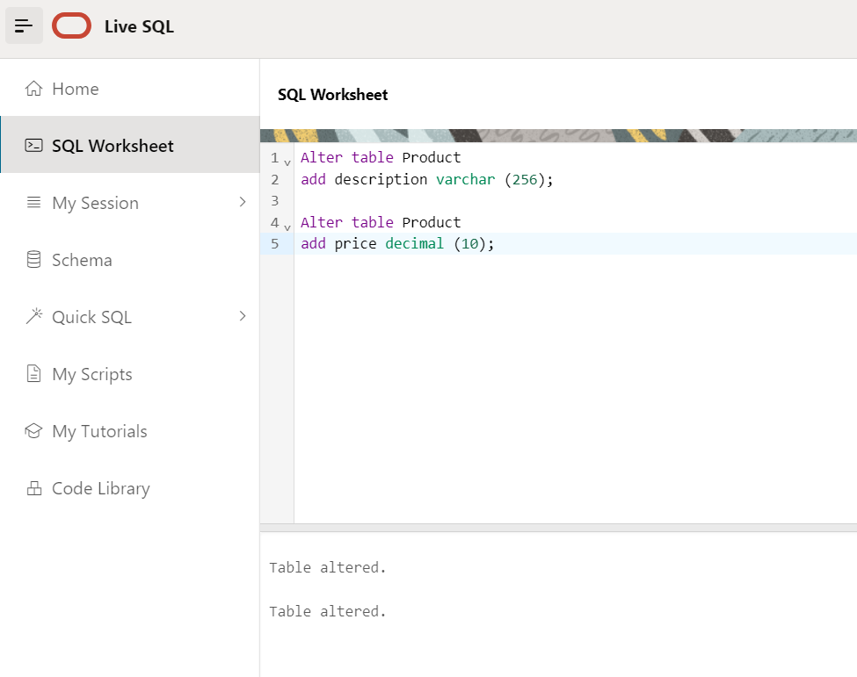

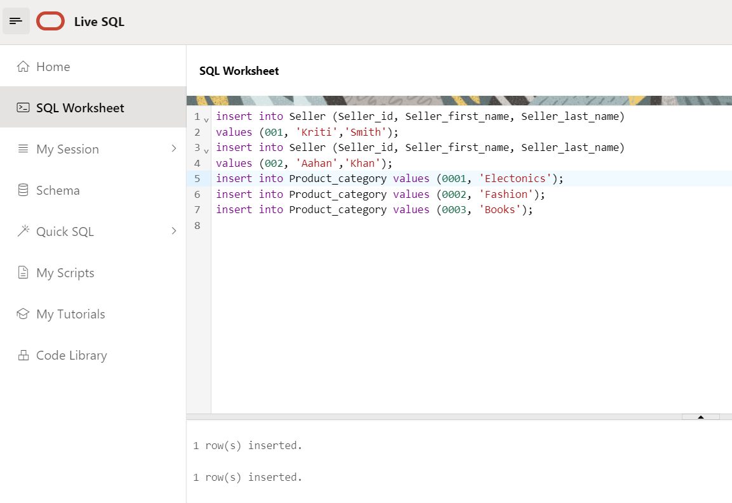

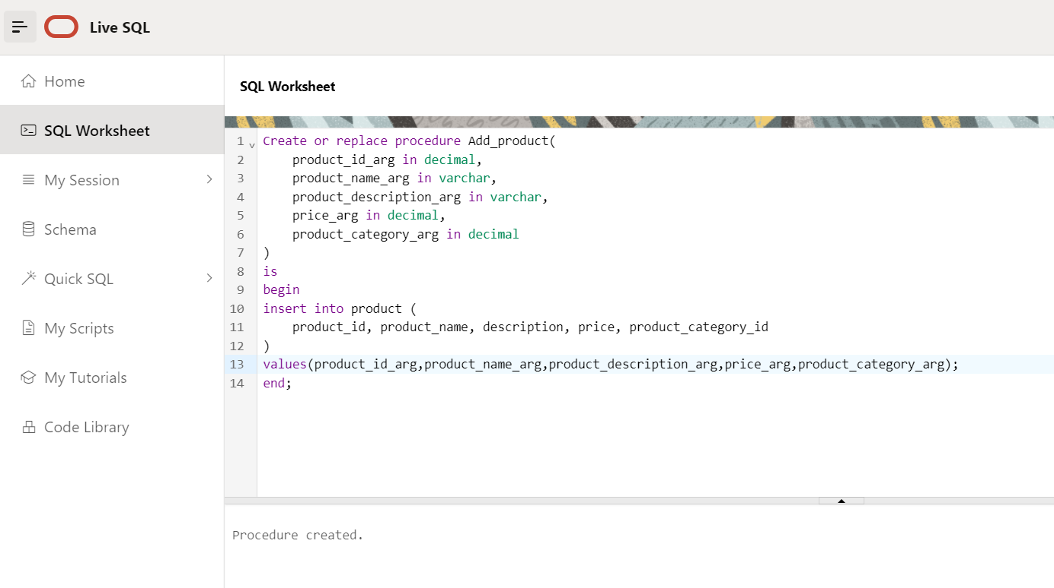

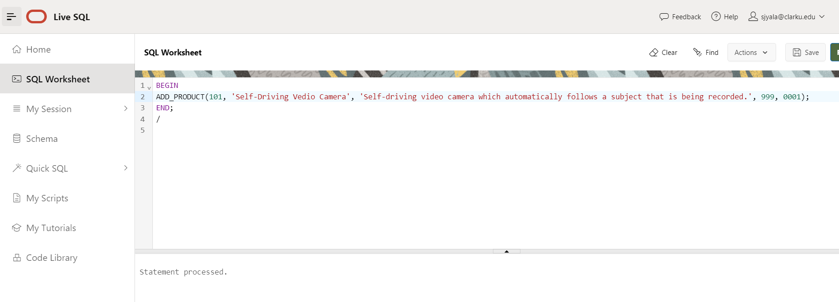

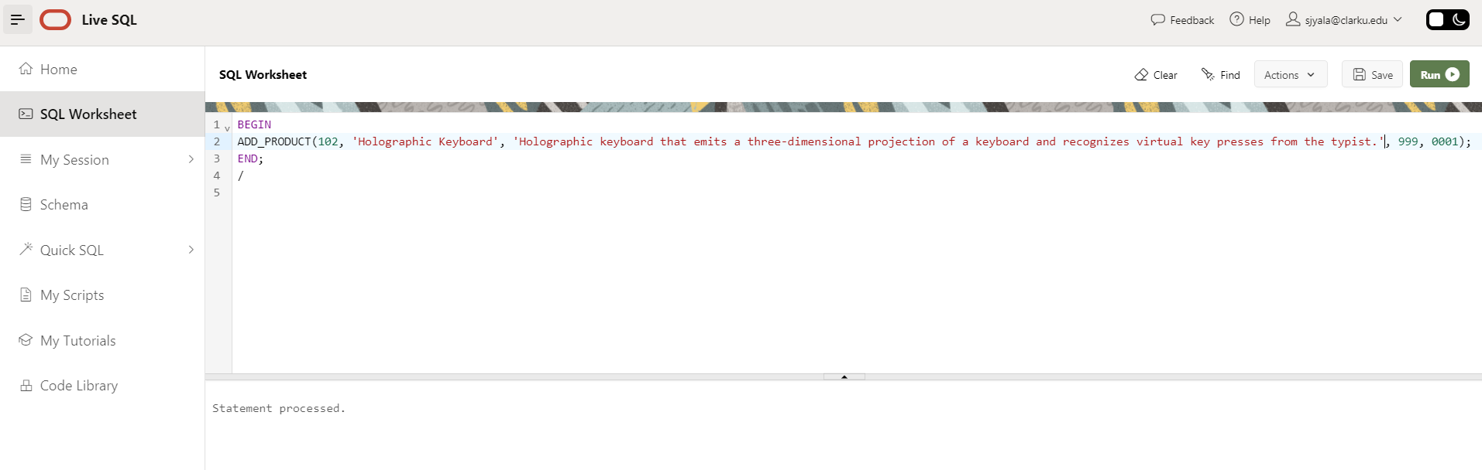

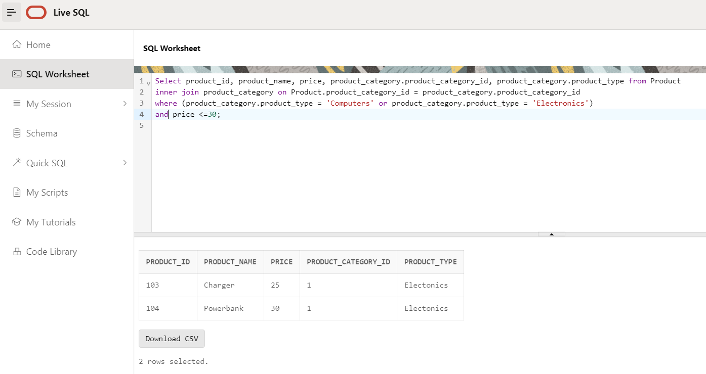

Aspect 2:
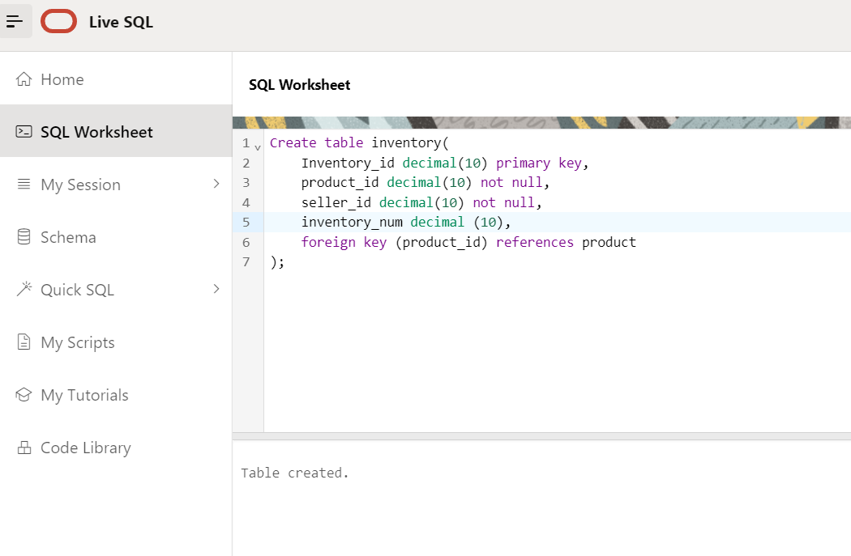

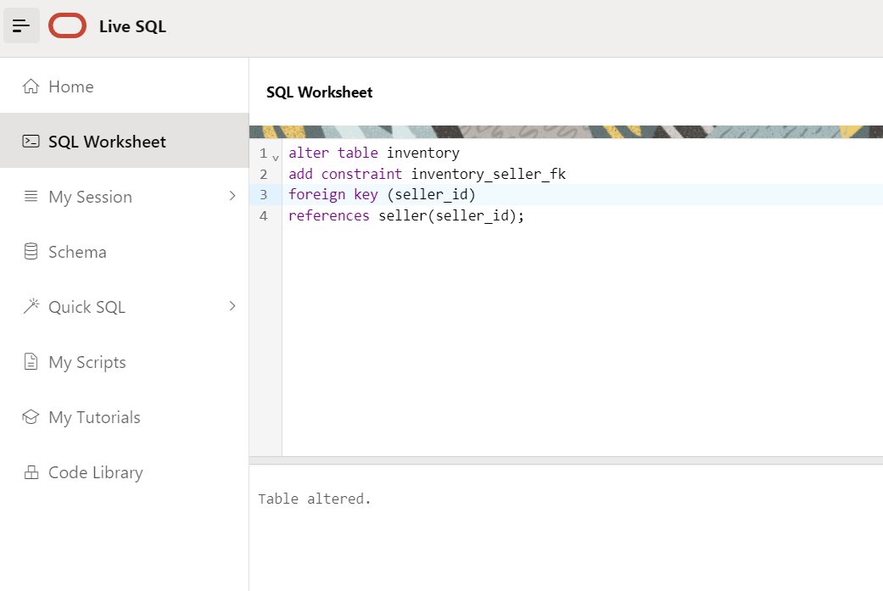
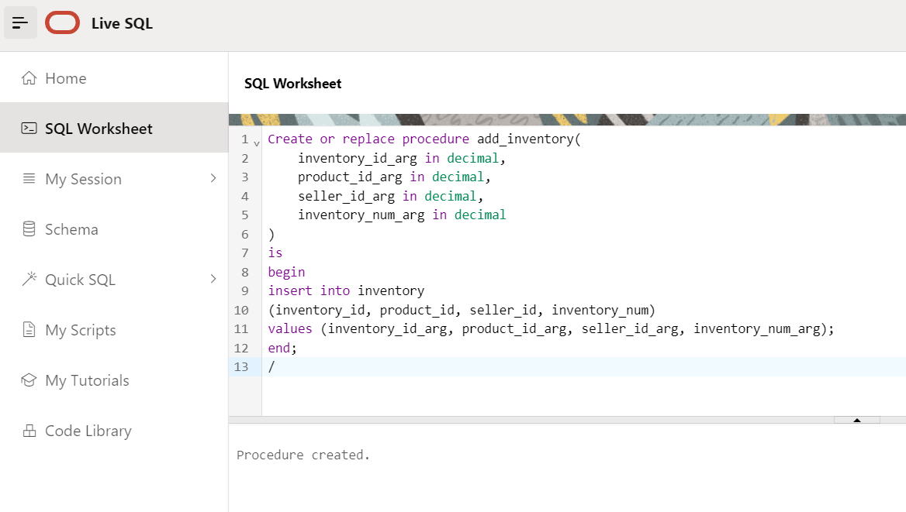

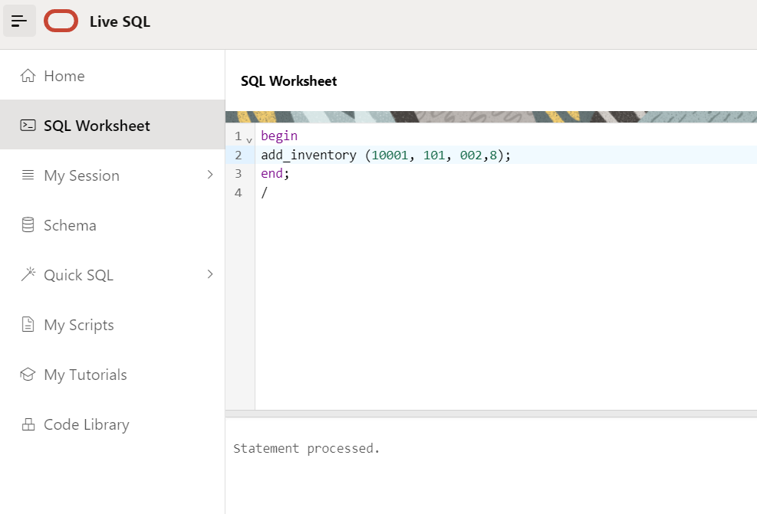
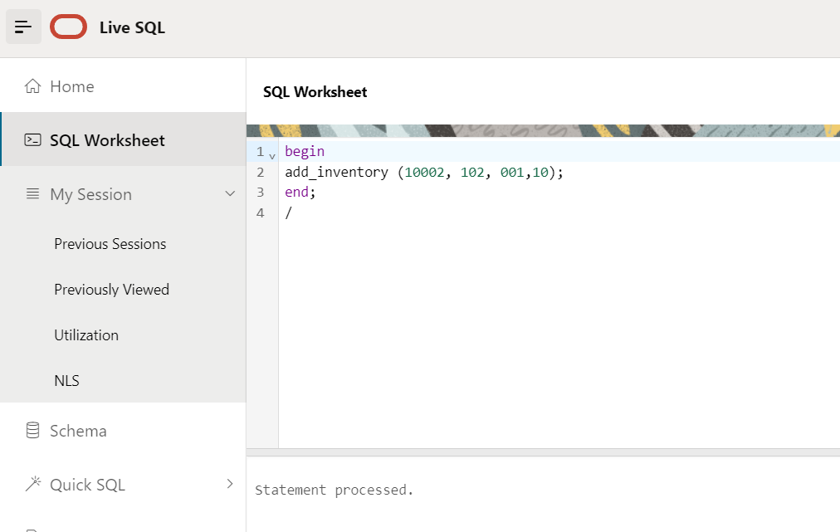
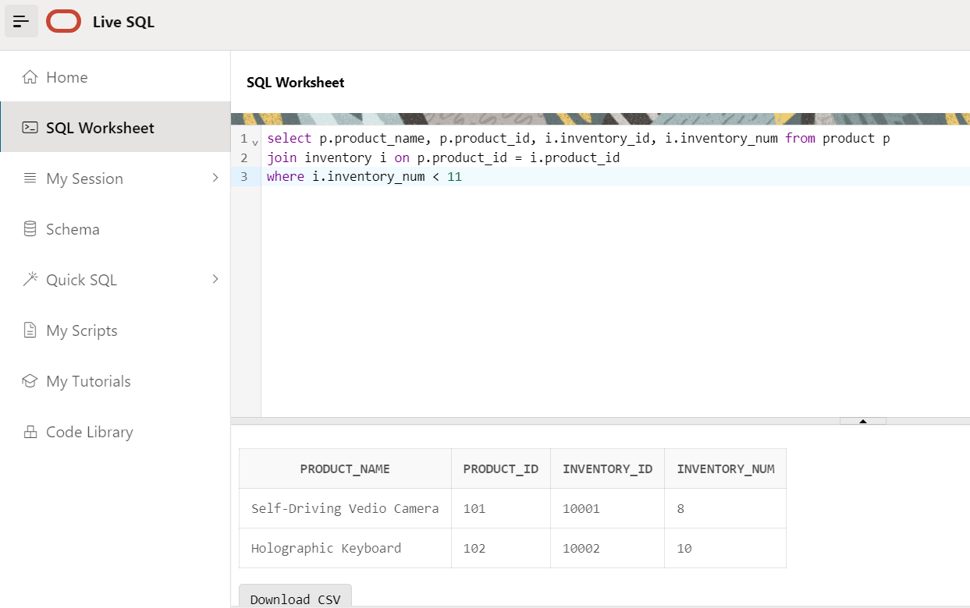

Aspect 3:
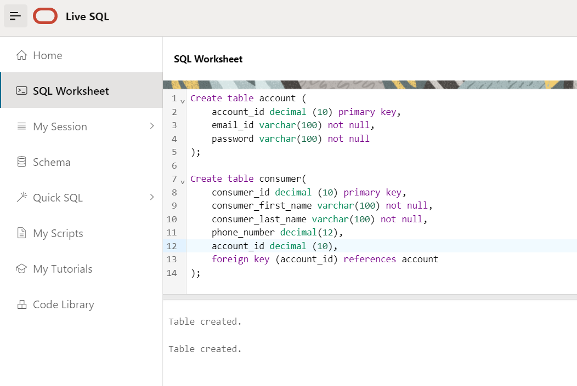

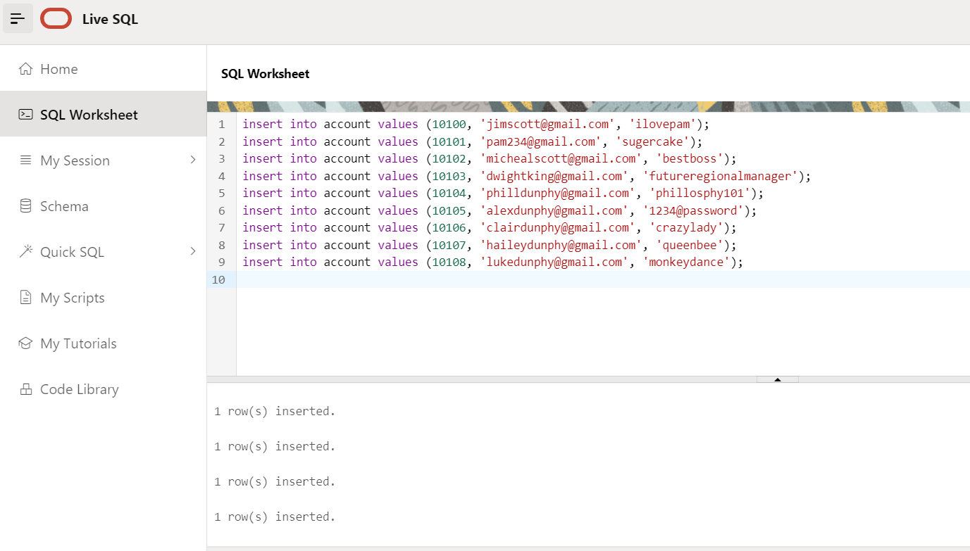

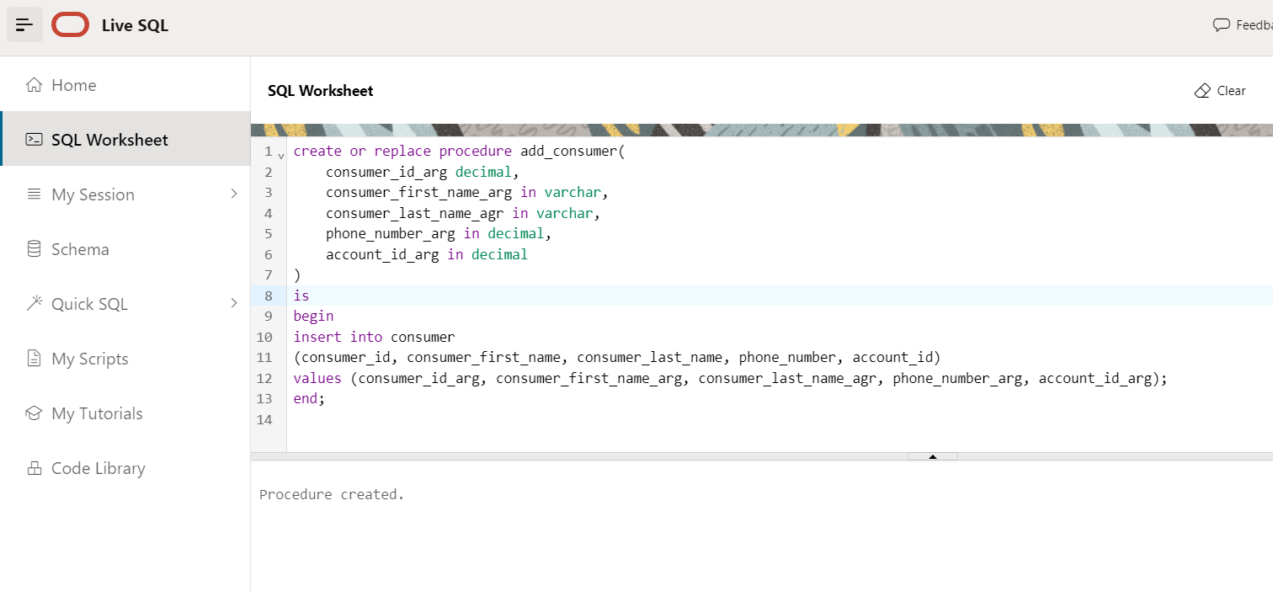

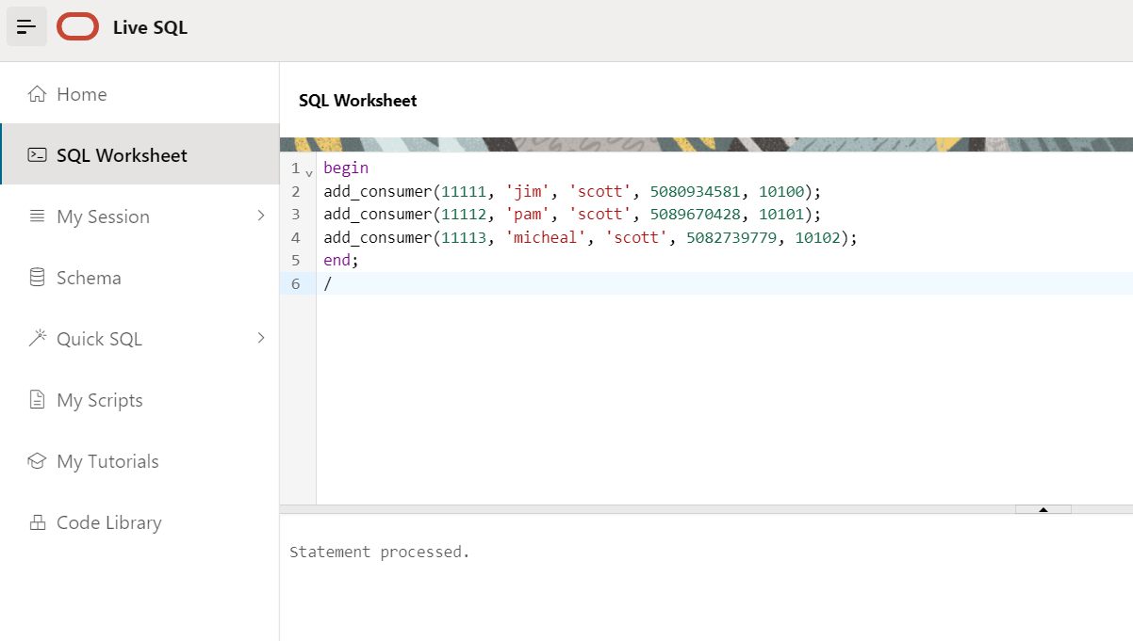

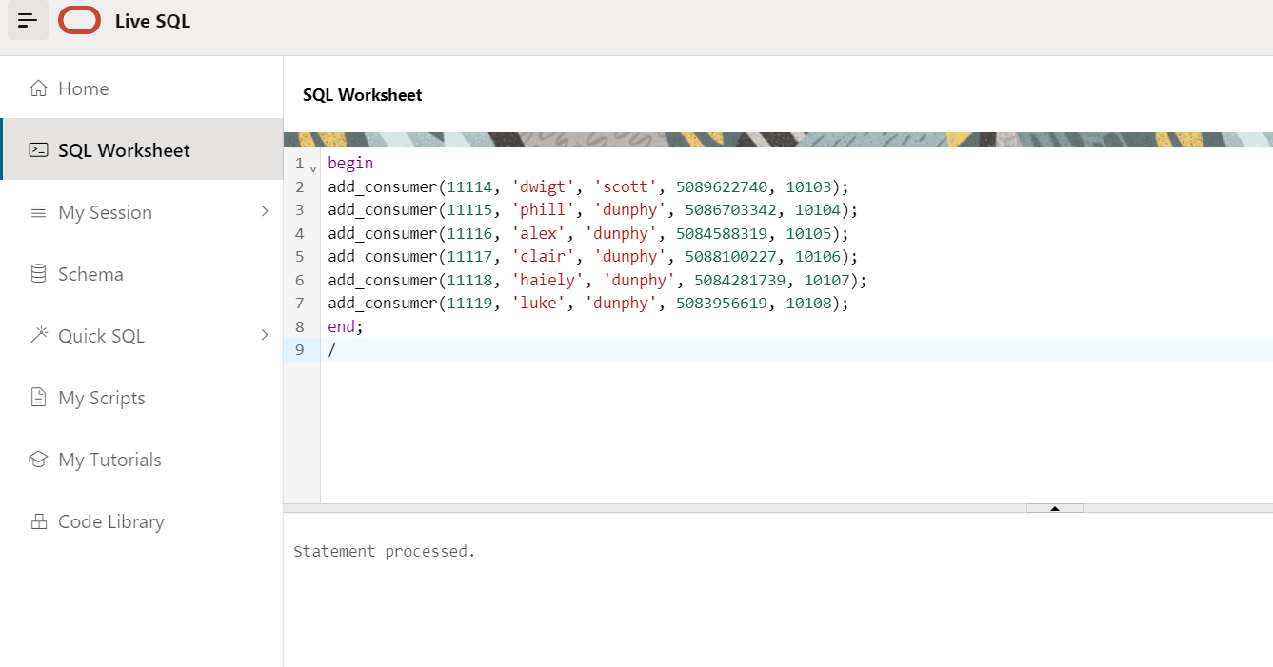

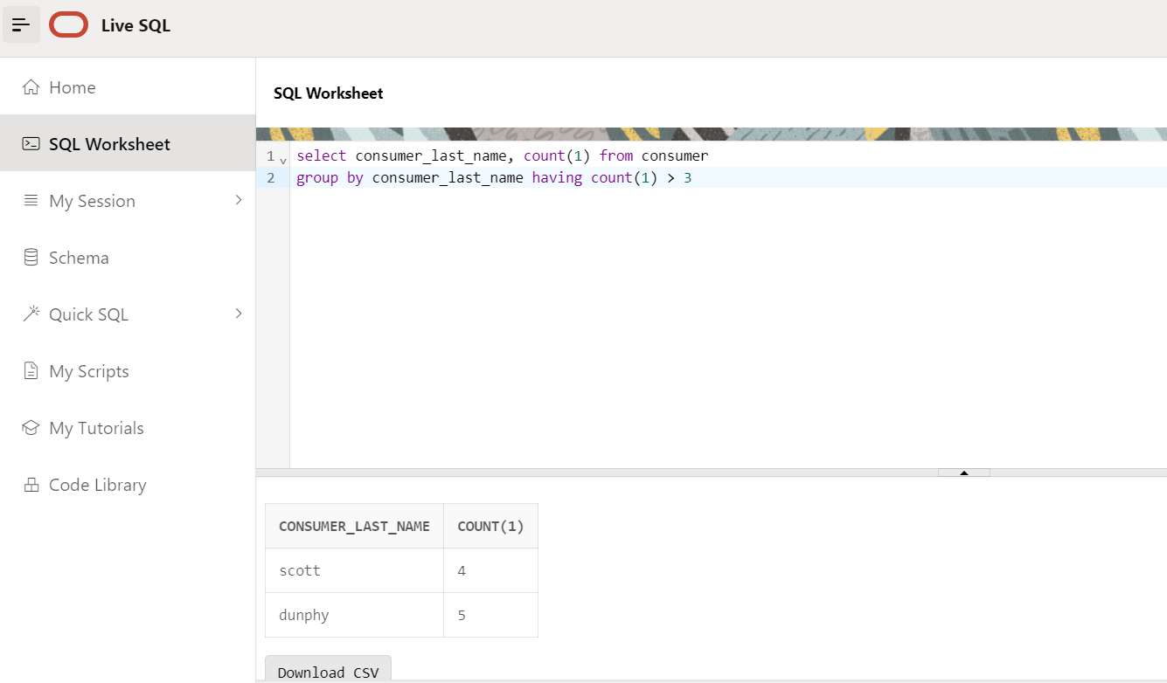

Aspect 4:
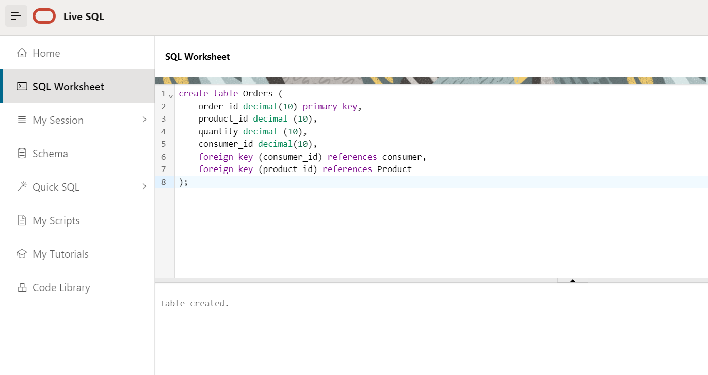

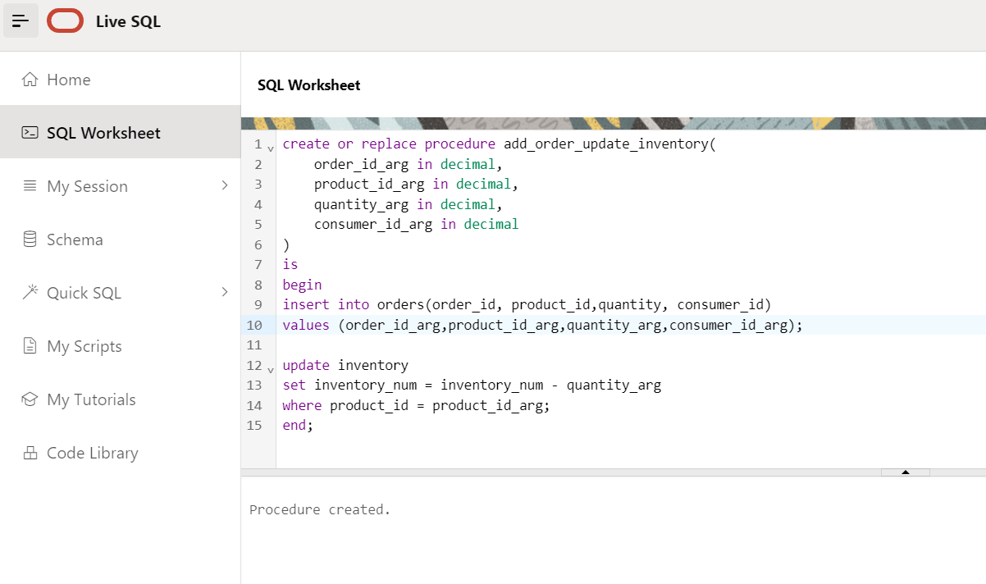
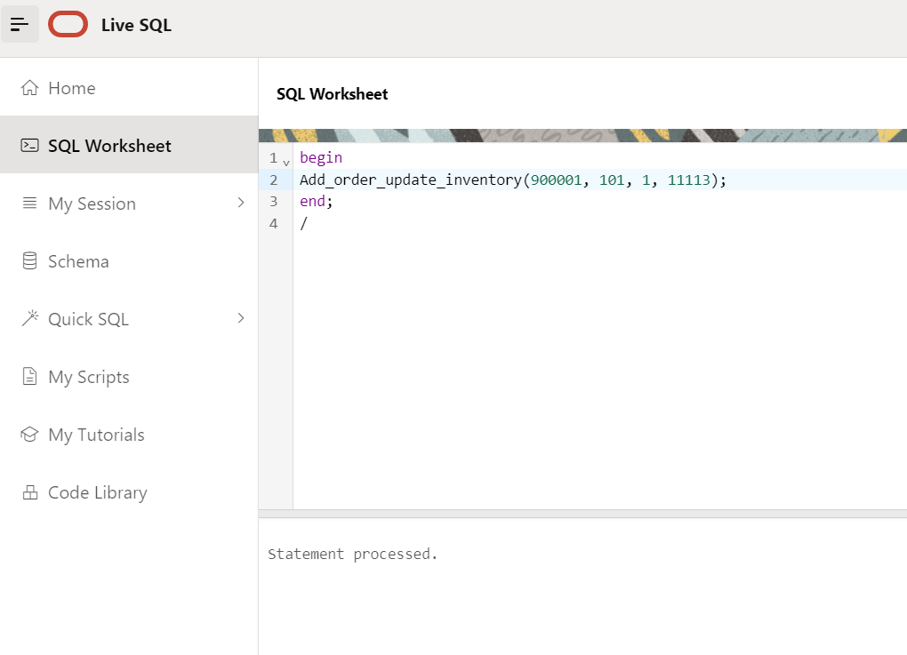

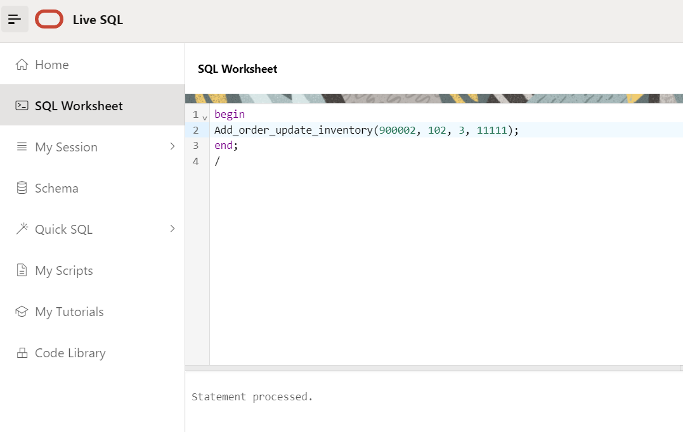

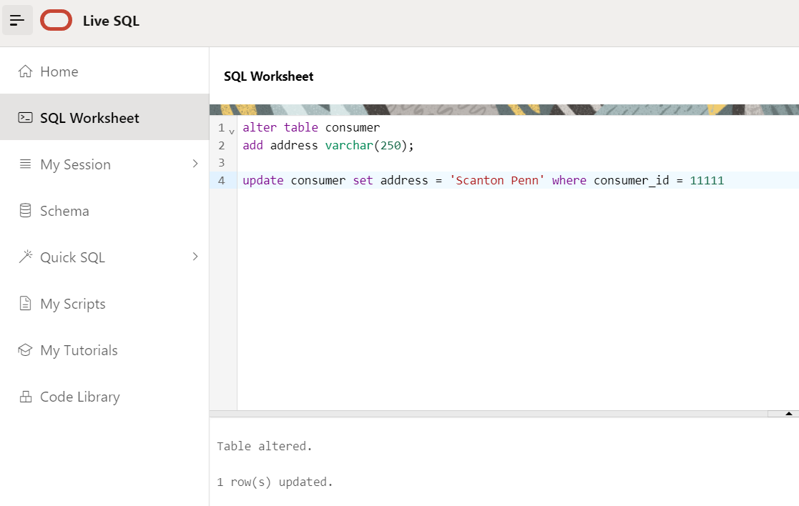

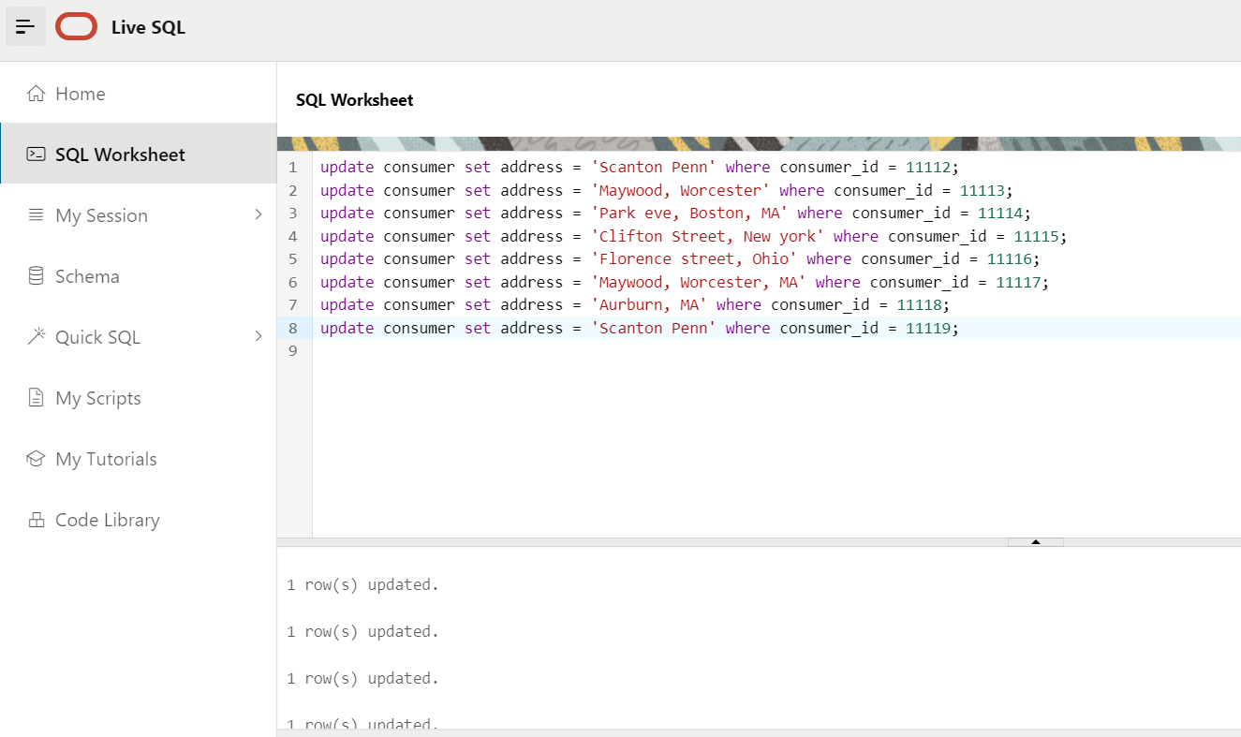

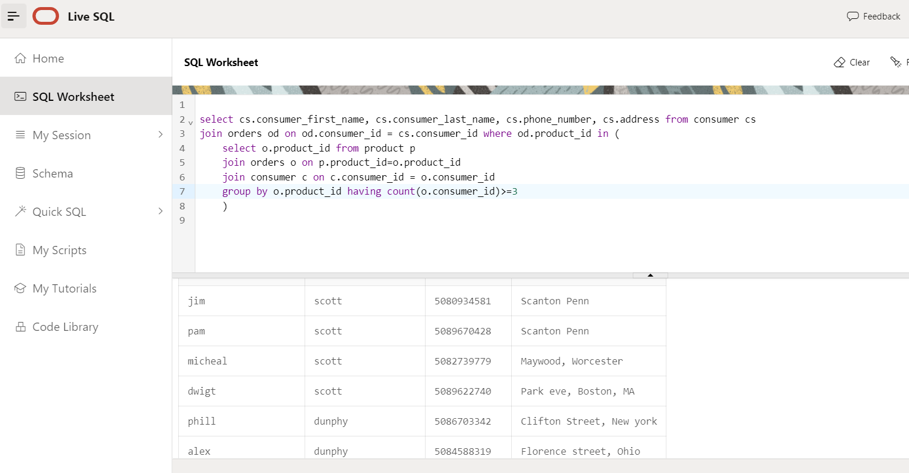
Note: Executed the procedure multiple times to make the purchase of the same product to get output in the above query.

Aspect 5:
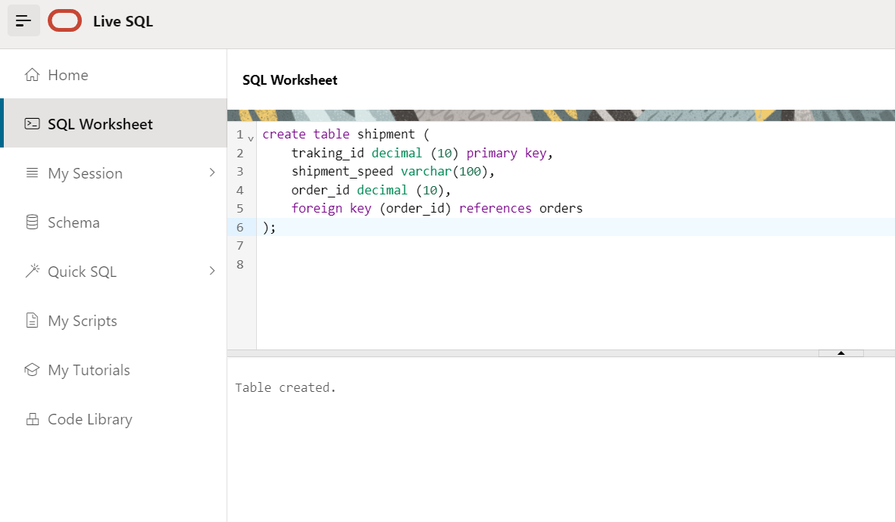
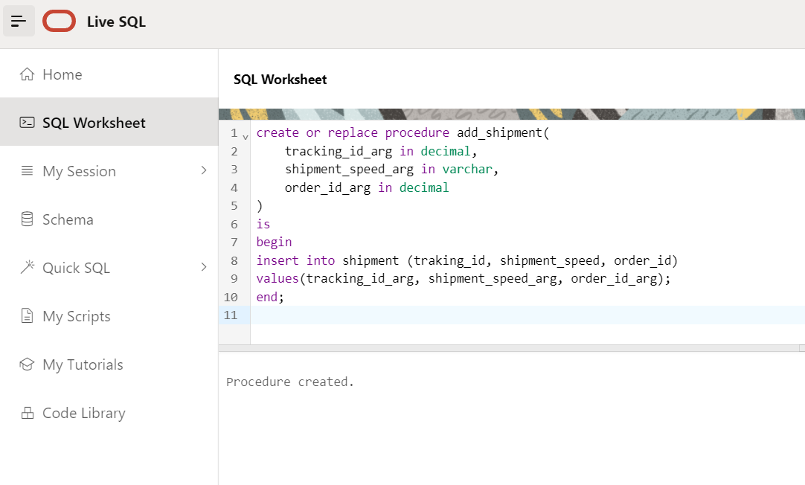

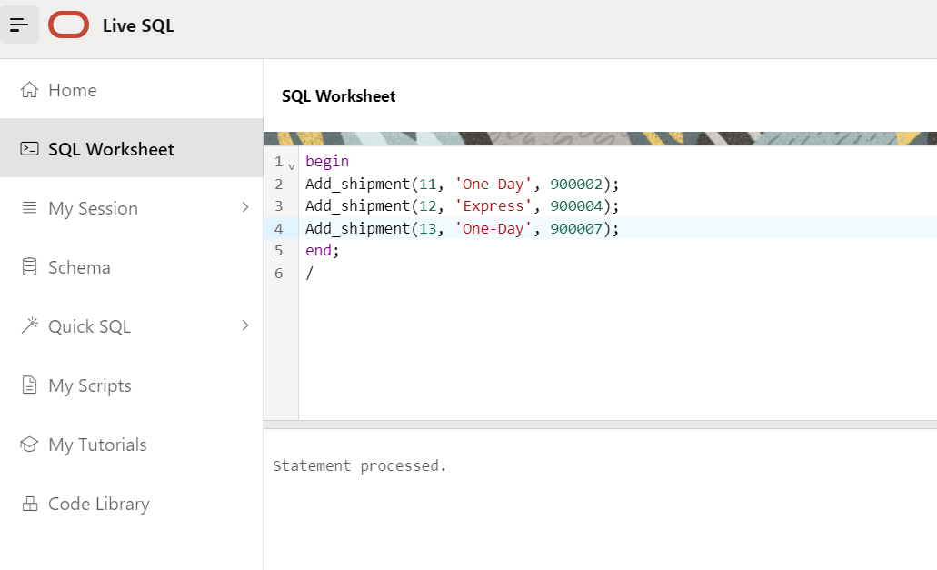

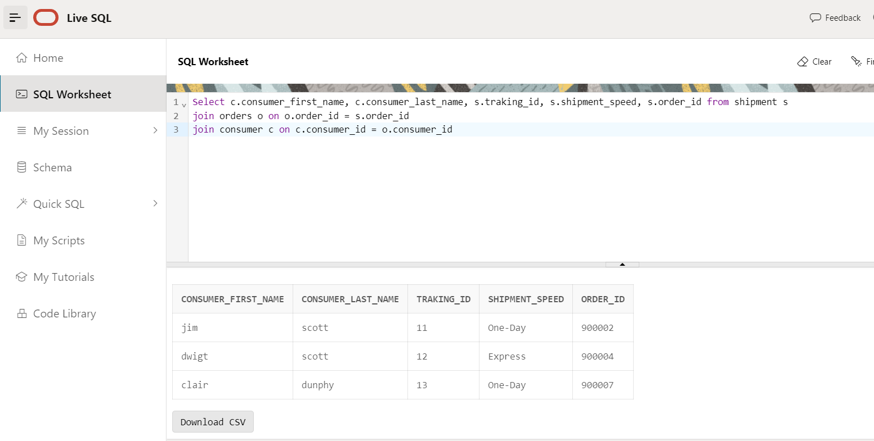

5.Index:

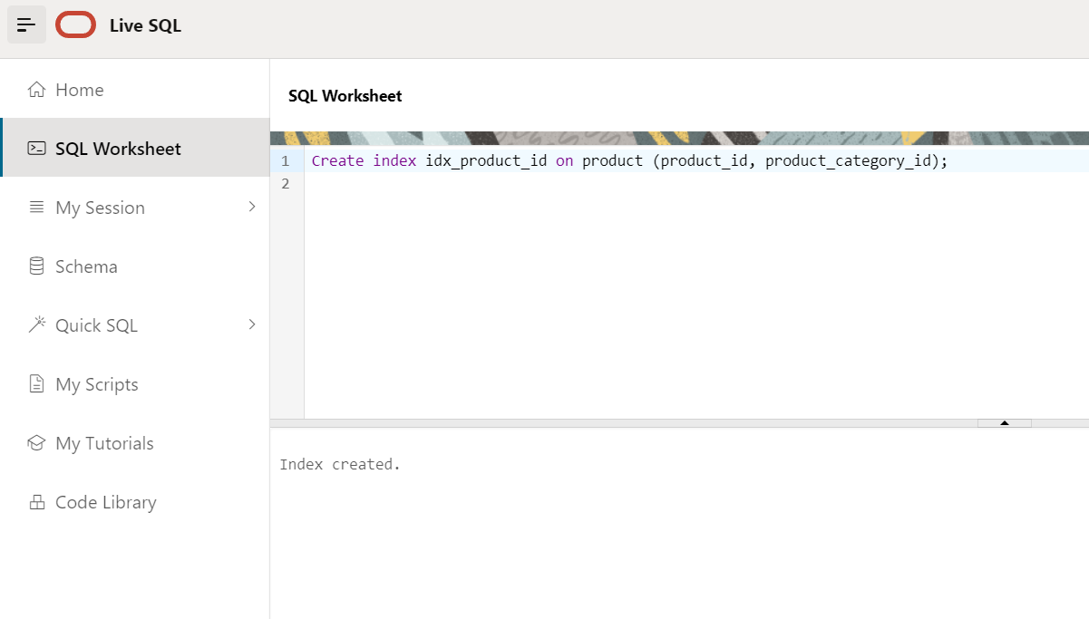

Index has been created on product ID, category ID in product table, as it will help amazon sellers to quickly check for product availability in inventory and Product Category.

